Report: n8n
After my Hermes Agent experiment, I also used my Hostinger (server hosting provider) account to test n8n.
n8n is a source-available, node-based workflow automation platform that connects applications, APIs and AI models into event-driven pipelines, built from pre-built integrations and custom JavaScript or Python code.
In the app different applications (e.g. email, Claude, Google Drive) can be connected using a visual interface or json.
For testing, I came up with the following use-case scenario: Imagine you are a recruiter and your inbox is constantly flooded with applications. Wouldn´t it be nice to have an automated workflow that extracts the CV and other application material from the email and then uploads it to google drive, while adding an initial assessment from your AI? In the following picture, you can see the workflow I built to tackle this problem:

One of the mayor advantages of n8n, is the fact that it combines simple conditions and loops with AI input (if required for a more complicated or unclear task). Therefore, costs are relatively low, for instance, running the workflow about seven times (I tested it with different “applicants” to see if the AI would find the best one) costed me roughly 7 cents.
Of course, the workflow can be improved and expanded as desired, for example, in reality, you would draft tailored replies for emails that don´t meet the requirements.

After my Hermes Agent experiment, I also used my Hostinger (server hosting provider) account to test n8n.
n8n is a source-available, node-based workflow automation platform that connects applications, APIs and AI models into event-driven pipelines, built from pre-built integrations and custom JavaScript or Python code. In the app, different applications (e.g. email, Claude, Google Drive) can be connected using a visual interface or by importing workflows in JSON format.
For testing, I came up with the following scenario: Imagine you are a recruiter and your inbox is constantly flooded with applications. Wouldn’t it be nice to have an automated workflow that extracts the CV and other application documents from each email, uploads them to Google Drive and adds an initial assessment written by AI? In the following picture, you can see the workflow I built with Claude to tackle this problem:
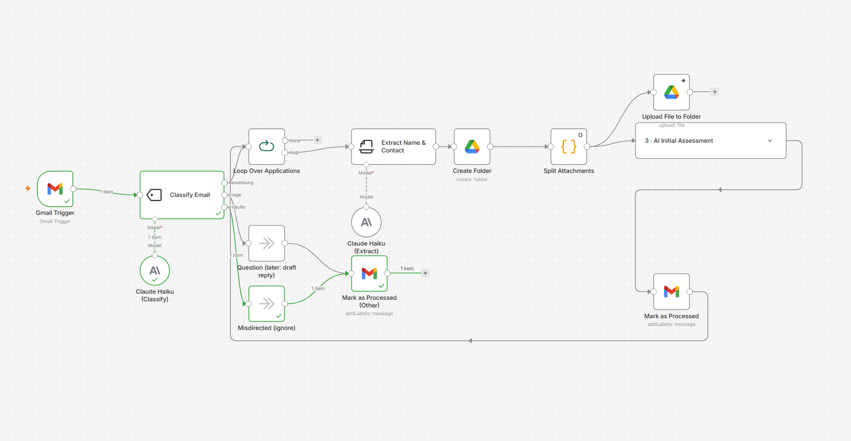
One of the major advantages of n8n is that it combines simple conditions and loops with AI input, which is only used where a task is more complex or ambiguous. As a result, costs are relatively low: running the workflow about seven times (I tested it with different “applicants” to see whether the AI would identify the best one) cost me roughly 8 US cents.
Of course, the workflow can be improved and expanded as desired. In a real-world setting, for example, you could have it draft tailored replies to applicants’ questions or send automatic confirmations of receipt.

